1 profile page edit option while viewing it detailed
2 fill the profile
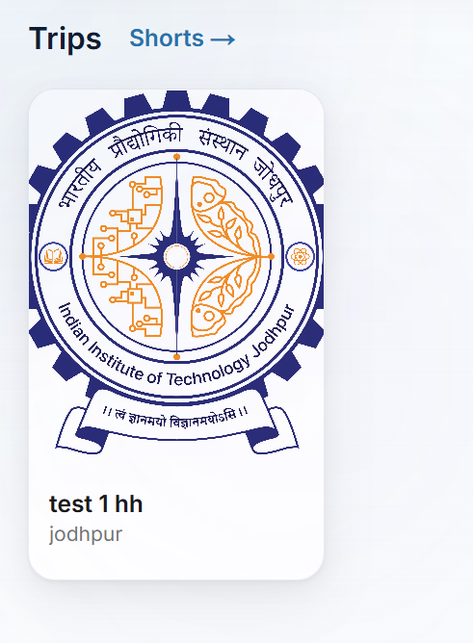
with like comment
if text overflows make it … to view the full text
3 detailed view page on the post need to change the ui
4 image is not aligned properly in detailed view page
5 . 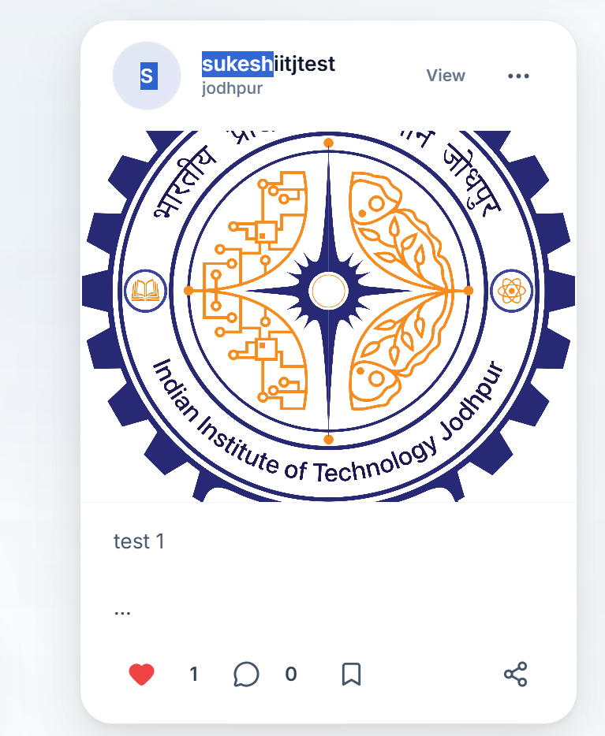
… needs to be functinal now its not working
5 like are not updating dynamically in different accounts
6 like are not updating in the detailed post view page also showing 0 like 0 conmmenst 0 likes · 0 comments
7. 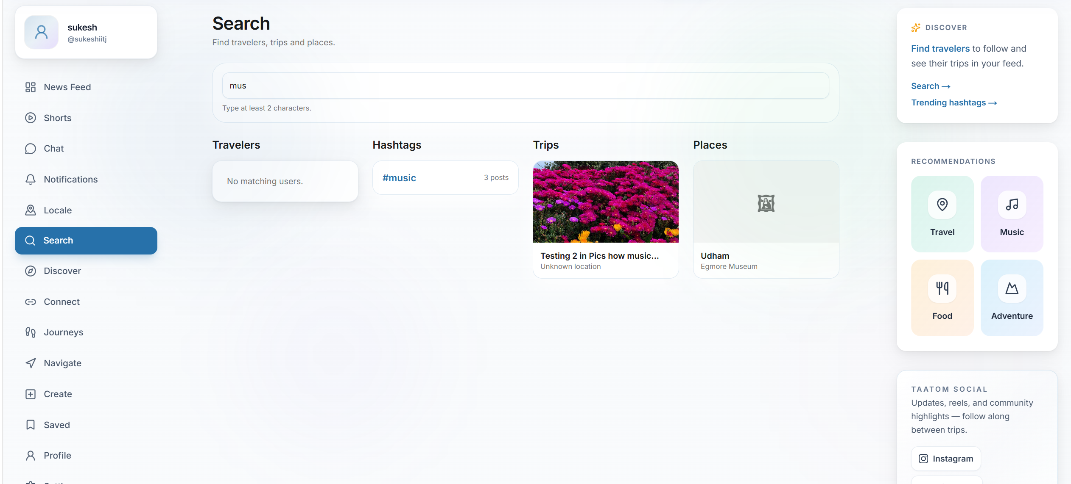
the hastah is shoing 3 post but its not showing the which are the 3 posts
8 in chat I share the image file in reciver chat the image exposes the image url as it is saved in db instead of it do some alias
what ever sharing in the chat the file url is exposed in the url bar
9.WHEN NEW MESSAGE COMES ITS NOT HIGHLIGHTED IN THE in the chat section
10 . and count of how many new messages arraived in that specific chat
11. In chat delete option edit the the message option in the chat message
12. Read recipet in chat tick option delivered like similar to whatsapp
13. While deleteing the chat custom delete dialog box is not showing like a popup for delete
make iy universal popup for all detele kind of things need to be customised popup make it global
while blocking also needed
14. Typing indicator in web
15 .chat optoin is not visiblen whin I minimise the window size the chatt functionality I cant find it
16. If user is blocked the details showing it to other user or not ned to check
17 pwa is available or not
16 completed

